LAB MANUAL 6
TAHA MUZAMMIL
456279
CW TASK 1
#include <iostream>
using namespace std;
int main() {
int x;

// Get the number of terms in the Fibonacci sequence needed
cout<< "how many numbers of the Fibonacci sequence are needed: ";
cin>> x;
int a=0,b=1,c;
cout<< "Fibonacci Sequence: ";
for (int i = 0; i < x; ++i) {
cout<< a << " ";
c=a+b;
a=b;
b=c;
// calculate the first and second number and update them for next iteration
}
}
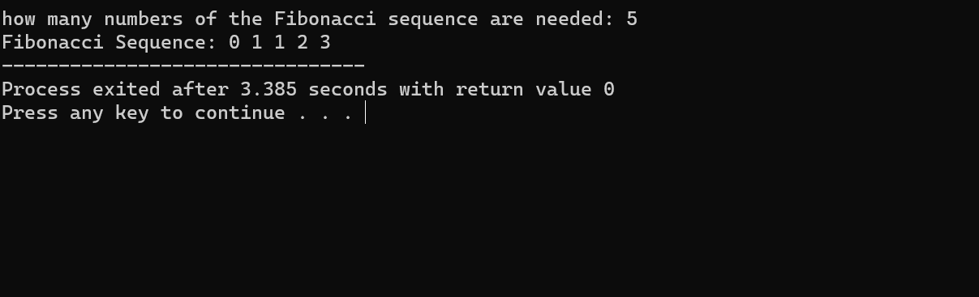

Task 2
#include <iostream>
using namespace std;
int main()
{
int x;
cout<< "Enter the number of rows for Floyd's Triangle: ";
cin>> x;
int num = 1;
for (int i = 1; i <= x; ++i) {
for (int j = 1; j <= i; ++j) {
cout<< num << " ";
++num;
}
cout<<endl;
}
}
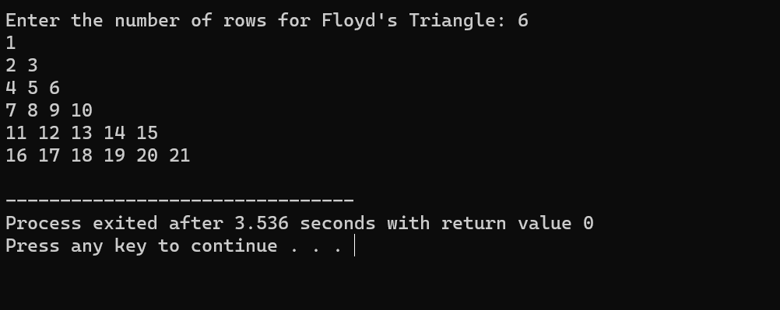
HW
#include <iostream>
using namespace std;
int main()
{
int sum= 0;

for (int n= 2; n<= 50; ++n) {
bool isPrime = true;
for (int i = 2; i <= n/ 2; ++i) {
if (n % i == 0) {
isPrime = false;
break;
}
}
if (isPrime) {
sum += n;
}
}
cout << "Sum of prime numbers from 1 to 50 is " << sum << endl;
}
